**Підсумкова контрольна робота**

**з англійської мови за ПС**

**студента групи КН-321**

**_________ __________**

**Варіант І**

1. ***Choose the correct answer.***

1. The bridge ..... by tomorrow morning.

a) will have been reconstructed

b) is being reconstructed

c) will be reconstructed

2. Everybody ..... by the terrible news yesterday.

a) shocked

b) was shocked

c) is shocking

3. Over 57 million students ..... in American schools which range from kindergartens to high schools.

a) were enrolled

b) are enrolled

c) has been enrolled

4. Let’s get together tonight. I want to talk about ..... a new business.

a) opening

b) open

c) to open

5. Peter, did you remember ..... the door? You are so absent-minded.

a) to lock

b) locking

c) lock

6. Sheila is very upset. She isn’t used ..... being treated like that.

a) on

b) to

c) in

7. Adam offered ..... for me tonight because he saw that I felt awful.

a) working

b) work

c) to work

1. … I leave the office half an hour earlier today?
2. Will c) May
3. Am d) Have
4. John came in … his suitcase.
5. carry c) carrying
6. carried d) being carried
7. He looked at a … copy of the newspaper.
8. fold c) to fold
9. being folded d) folded
10. ***Translate into English.***
11. Блок-схема програми
12. мова запитів
13. цикл
14. дочірній запис
15. мережева модель бази даних
16. журнал транзакцій
17. програмне забезпечення для електронних таблиць
18. автоматизоване проектування
19. початкове завантаження програми
20. прикладне програмне забезпечення
21. ***Match the terms in Table A with the statements in Table B.***

|  |  |
| --- | --- |
|  |  |

**IV.Read the text and answer the following questions.**

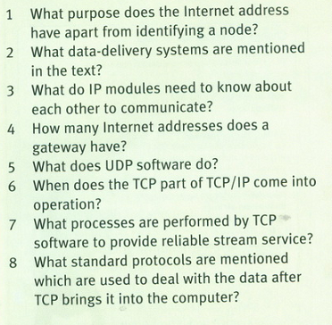

|  |  |
| --- | --- |
|  |  |

***V. Write about your favourite programming language and explain why it is your favourite one. Use not less than 15 sentences.***

***_______________________________________________________________________________________________________________________________________________________________________________________________________________________________________________________________________________________________________________________________________________________________________________________________________________________________________________________________________________________________________________________________________________________________________________________________________________________________________________________________________________________________________________________________________***

**Підсумкова контрольна робота**

**з англійської мови за ПС**

**студента групи КН-321**

**__________ ___________**

**Варіант ІІ**

1. ***Choose the correct answer.***

1.Our plan ..... by the members of the committee at the moment.

a) considers

b) is being considered ++++

c) is considered

2. Many accidents ..... by dangerous driving.

a) caused

b) are caused +++

c) have been caused

3. It's a big company. It ..... two hundred people.

a) is employed

b) employs +++

c) employing

4. The room ..... later.

a) will clean

b) will be cleaned +++

c) has been cleaned

5. I enjoy making practical jokes about people, but I hate ..... fun of.

a) being made

b) to make

c) making ++

6. George has a Newfoundland dog, Strickland by name, and he is responsible ..... it twice a day.

a) for walking +++

b) walk

c) to walk

7. The teacher had to stop several times ..... the rule because she saw that it was difficult for the children to understand it.

a) explaining

b) to explain +++

c) explain

1. If she follows the doctor’s advice now, she … to skate again soon.
2. can c) will be able
3. has to +++ d) must
4. It was the first time he looked …
5. excite +++
6. c) being excited
7. exciting d) excited
8. For a moment he stood as if … for another question.
9. waiting +++ c) waited
10. wait d) being waited
11. ***Translate into English.***
12. програмне забезпечення системи управління базами даних database management system software
13. програмне забезпечення для обробки текстів   
    word processing software
14. генератор звітів report generator

повторення repetition

реляційна модель бази даних relational database model

кореневий запис root record

незалежність програми independence of programs

інтегроване середовище розробки integrated development environment

Псевдокод pseudocode

1. зовнішні командні інструкції

external command instructions

***III.Match the terms in Table A with the statements in Table B.***

|  |  |
| --- | --- |
|  |  |

A iii

B v

C i

D ii

e iv

**IV.Read the text and answer the following questions.**

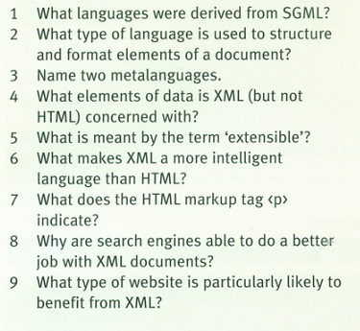

|  |  |
| --- | --- |
|  |  |

1. ***Write why you decided to become a programmer, what are the pluses and minuses of this profession. Use not less than 15 sentences.***

***First of all, I chose this profession because it is highly paid.*** Good programmers can get a job in an IT company and earn a lot of money. But programming is quite difficult . You need to know math well and think logically